TRITAP SATELLITE SAFETY RING
Dr.N.MUTHUVAIRAVAN PILLAI¹ , ASHVITHA S P² ,NIVETHASHREE D ³,
¹ Associate Professor, Department of Computer Science and Business Systems, R.M.D. Engineering College, Tamil Nadu - 601 206, muthu.csbs@rmd.ac.in
² Student, Department of Computer Science and Business Systems, R.M.D. Engineering College, Tamil Nadu - 601 206, sash.csbs2024@rmd.ac.in
³ Student, Department of Computer Science and Business Systems, R.M.D. Engineering College, Tamil Nadu - 601 206, dniv.csbs2024@rmd.ac.in

ABSTRACT— The Tri Tap Satellite Safety Ring is an innovative wearable safety device designed to provide instant emergency assistance using a simple triple-tap activation mechanism. The system integrates IoT technology, GPS tracking, and satellite/GSM communication to send real-time SOS alerts without the need for a smartphone. It detects user input through a tap sensor and transmits the user’s location and body temperature to predefined emergency contacts.
The device ensures reliable communication even in remote areas such as forests and mountains by enabling satellite-based connectivity. This system enhances personal safety, reduces emergency response time, and provides continuous monitoring, making it suitable for women, elderly individuals, and travellers.
I.INTRODUCTION
The Tri Tap Satellite Safety Ring is a smart wearable device designed to enhance personal safety using advanced embedded and communication technologies. In today’s world, individuals often face emergency situations where accessing a mobile phone is difficult or time-consuming. Traditional safety methods rely heavily on smartphones and manual communication, which may not be effective during critical moments.

To address this issue, the proposed system introduces a compact and user-friendly ring that can send an emergency alert through a simple triple-tap action. The device integrates sensors, a microcontroller, and communication modules to detect the tap signal, capture real-time location using GPS, and transmit an SOS message to predefined contacts. Additionally, it includes body temperature monitoring to provide health-related information during emergencies.

The system is designed to function even in remote areas by supporting satellite or GSM-based communication, ensuring reliable connectivity without depending on smartphones. By automating the emergency alert process, the Tri Tap Satellite Safety Ring improves response time, enhances personal security, and reduces dependency on manual actions. This innovative solution is especially useful for women, elderly individuals, children, and travellers, providing a safe and efficient way to handle emergency situations.
II.OBJECTIVE
The objective of the Tri Tap Satellite Safety Ring is to provide a quick, reliable, and easy-to-use personal safety solution using wearable technology. The system aims to enable users to send an emergency alert instantly through a simple triple-tap action without needing to access a mobile phone.

The device is designed to detect the tap signal, capture real-time location using GPS, and transmit an SOS message to predefined emergency contacts through GSM or satellite communication. It also monitors the user’s body temperature to provide additional health information during emergencies.

Another objective is to ensure safety in remote areas such as forests or isolated locations where network connectivity may be limited. Overall, the goal of the system is to improve personal security, reduce emergency response time, and provide a smart, efficient, and user-friendly safety solution.

III. EXISTING

In the existing system, personal safety mainly depends on mobile phones, safety apps, or manual communication methods. Users need to unlock their phones, open an application, and send an alert, which may not be possible during emergency situations.

Most existing safety solutions rely on Bluetooth or internet connectivity, which can fail in remote areas. Additionally, these systems do not provide integrated health monitoring features such as body temperature tracking.

As a result, the existing system is less effective, time-consuming, and highly dependent on user interaction and network availability.

IV. CHALLENGES FACED

Implementing the Tri Tap Satellite Safety Ring involves several challenges. One major challenge is the miniaturization of electronic components to fit into a compact ring design while maintaining performance.

Another challenge is ensuring accurate detection of the triple-tap signal, as false triggers or missed taps can affect reliability. Power management is also a key issue, as the device must operate efficiently with a small battery for longer durations.

Communication in remote areas can be challenging, requiring reliable GSM or satellite modules. Additionally, integrating multiple functionalities such as GPS tracking, temperature monitoring, and emergency communication into a single wearable device increases system complexity.

Overall, overcoming these challenges is essential to develop a reliable, efficient, and practical safety device.

V. PROPOSED SYSTEM
The proposed Tri Tap Satellite Safety Ring is designed to enhance personal safety by providing a fast and reliable emergency alert system using wearable technology. In this system, the user wears a smart ring equipped with a tap detection sensor, microcontroller, GPS module, and communication module.

When the user taps the ring three times within a short duration, the system detects the signal and activates the emergency process. The device immediately captures the user’s real-time location using GPS and measures body temperature through an integrated sensor. This information is then transmitted as an SOS alert to predefined emergency contacts using GSM or satellite communication, ensuring connectivity even in remote areas.

The system is designed to operate independently without requiring a smartphone, making it highly efficient during critical situations. The alert message includes essential details such as location coordinates and health status, allowing quick response from rescue teams or family members.

By combining smart sensing, real-time tracking, and automated communication, the proposed system provides a compact, reliable, and user-friendly safety solution, reducing emergency response time and improving personal security.
VI. ADVANTAGES

The Tri Tap Satellite Safety Ring offers several advantages in improving personal safety and emergency response. One major advantage is instant activation through a simple triple-tap action, which eliminates the need to access a mobile phone during emergencies.

The system provides real-time location tracking using GPS, allowing quick identification of the user’s position. It also includes body temperature monitoring, which helps provide additional health information during critical situations.

Another key advantage is its ability to function in remote areas using GSM or satellite communication, ensuring reliable connectivity even without internet access. The device is compact, lightweight, and wearable, making it easy to use in daily life.

By automating the alert process and reducing manual effort, the system enhances safety, minimizes response time, and provides a smart and efficient personal security solution.
VII.COMPONENTS REQUIRED
The Tri Tap Satellite Safety Ring requires a combination of hardware components to ensure effective operation and reliable performance. The primary component is a microcontroller, such as ESP32, which acts as the central processing unit and controls all system functions.

A tap detection sensor is used to identify the triple-tap input from the user and trigger the emergency alert. A GPS module is integrated to capture real-time location coordinates, while a communication module (GSM or satellite) is used to transmit the SOS message to emergency contacts.

The system also includes a body temperature sensor to monitor the user’s health condition during emergencies. A rechargeable lithium-ion battery is used to power the device, along with a voltage regulator to maintain stable power supply.

Additional components such as a PCB or breadboard, connecting wires, and a small casing are used to assemble and protect the circuit. The ring prototype acts as the wearable trigger device, while the main electronic components are housed in a compact module.

Together, these components form a smart wearable system designed to provide quick, reliable, and efficient emergency assistance
VIII. FLOW CHART
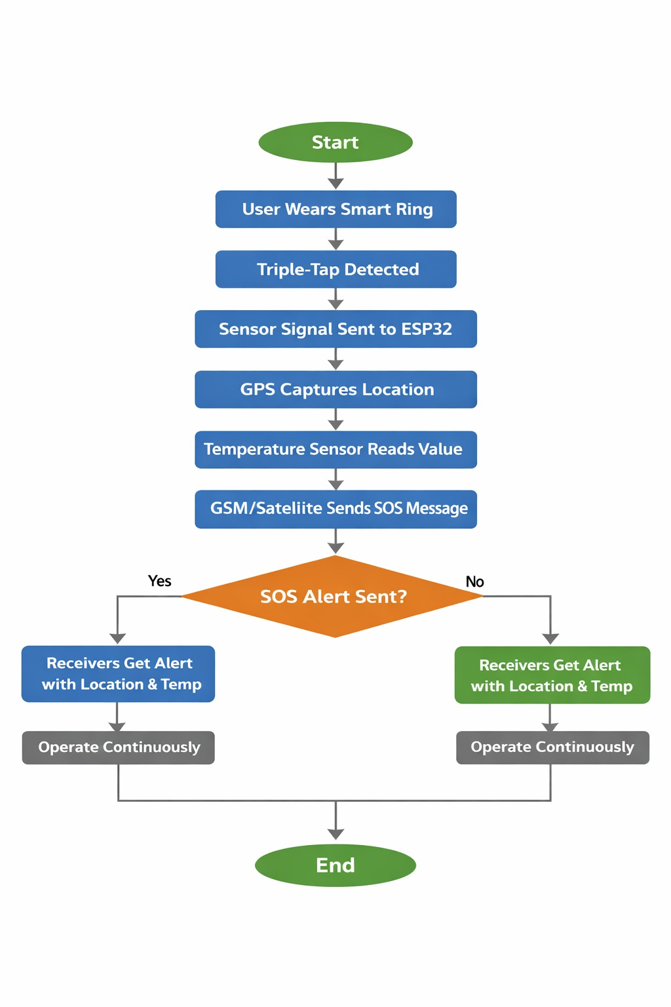

Fig VIII.1

IX . OUTPUT
The output of the Tri Tap Satellite Safety Ring includes instant emergency alerts, real-time location tracking, and health monitoring data. When the user performs a triple tap on the ring, the system detects the signal and immediately processes it.

The device captures the user’s current location using GPS and measures body temperature through the sensor. This information is then transmitted as an SOS message to predefined emergency contacts using GSM or satellite communication.

In emergency situations, the system ensures quick notification delivery even in remote areas, enabling faster rescue response. Additionally, the alert message contains critical details such as location coordinates and health status, which help responders take appropriate action.

Overall, the system provides a reliable and efficient output by combining automatic alert generation, real-time tracking, and health monitoring.
X. REFERENCE
1.Kumar, S., et al. IoT-Based Smart Safety Systems for Personal Security.
https://www.ijert.org/iot-based-women-safety-device
2.Gupta, N., & Agarwal, B. B. Wearable Emergency Alert Systems using IoT.
https://etasr.com/index.php/ETASR/article/view/
3.Mahajan, K. N., et al. GPS and GSM Based Emergency Alert System.
https://repo.ijiert.org/index.php/ijiert/article/view/
4.Wang, J., et al. Smart Wearable Devices for Emergency Communication.
https://www.mdpi.com
5.Anusha, K., et al. IoT-Based Smart Safety Device.
https://www.ijert.org
6.Prathyusha, T. IoE-Based Safety Systems.
https://www.ijariit.com
7.Akhil, M. V., et al. Smart Wearable Safety Devices.
https://www.ijariit.com
8.Gurusamy, P. Artificial Intelligence in Wearable Safety Systems: A Review.
https://eduac.in
9.Internet of Things for Safety and Emergency Monitoring Systems.
https://www.sciencedirect.com
10.Survey on Smart Security and Safety Systems.
https://www.ijraset.com
11.Deshpande, A., & Deshpande, V. Human Activity Recognition using Sensors.
https://arxiv.org

